|  |  |  |  |  |
| --- | --- | --- | --- | --- |
| **National University of Computer and Emerging Sciences, Lahore Campus** | | | | |
| C:\Users\saif\AppData\Local\Microsoft\Windows\Temporary Internet Files\Content.Word\final design.jpg | **Course:** | **Applied Physics** | **Course Code:** | **EE117** |
| **Program:** | **BS (CS), BS (DS), BS (SE)** | **Semester:** | **Fall 2020** |
| **Duration:** | **4 years** | **Total Marks:** | **40** |
| **Date:** | **20-10-2020** | **Weight:** | **15%** |
| **Section(s):** | **All** | **Page(s):** | **6** |
| **Exam:** | **Midterm 1** | **Max. Time** | **90 minutes** |
| **Name:** |  | **Roll No./Section** |  |
| **Instructions/Notes:** | **Attempt all questions.**  **Write your answer within the space provided only.**  **Do not attach any rough sheet with the paper.** | | | |

**Question 1(a):** You are standing $100 m$ north of your car when an alligator appears $20 m$ north of you and begins to run toward you at $8 m/s$. At the same moment you start to run toward your car at $5 m/s$. (a) Will you reach the car before the alligator overtakes you? (b) If not, how far from your car does the alligator have lunch? (10 marks)

**Solution:**

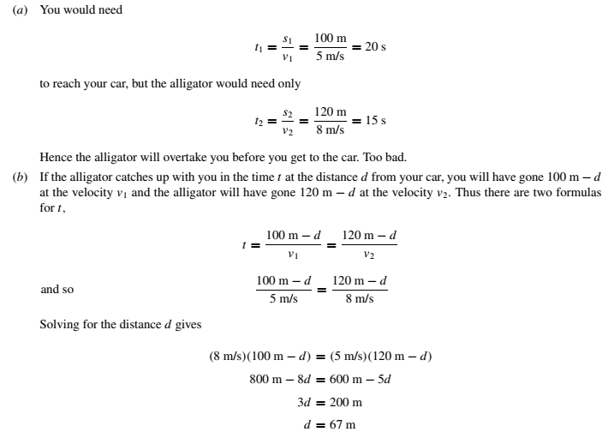

**Question 1(b):** A map suggests that Atlanta is $730$ miles in a direction $5.00°$ north of east from Dallas. The same map shows that Chicago is $560$ miles in a direction $21.0°$ west of north from Atlanta. Figure shows the location of these three cities. Modeling the Earth as flat, use this information to find the displacement from Dallas to Chicago. (10 marks)

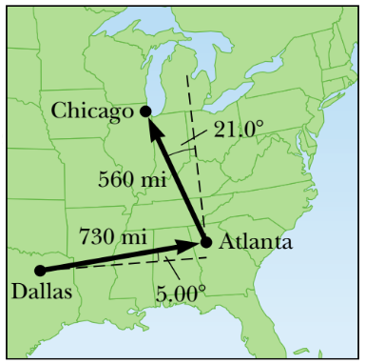

**Solution:**

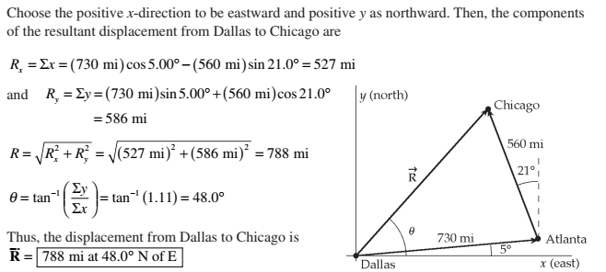

**Question 2 (a):** An athlete participates in a long–jump competition, leaping into the air with a velocity $v_{0}$ at an angle $θ_{0}$ with the horizontal. Derive the expression for the maximum displacement in vertical direction, $Δy_{max}$, in terms of $v_{0},θ_{0},$ and $g$. (3 marks)

**Solution:**

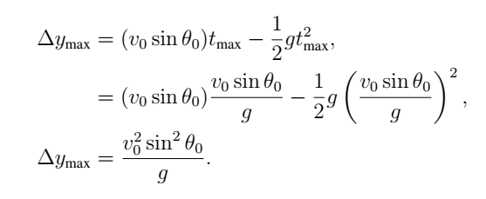

**Question 2 (b):** A rock is kicked horizontally at 15 m/s from a hill with a 45 *◦* slope (see Fig. below).  
How long does it take for the rock to hit the ground? (7 marks)

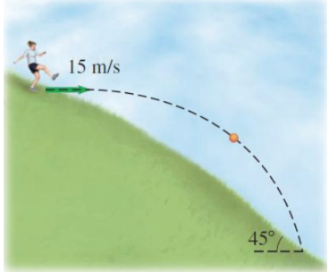

Solution:

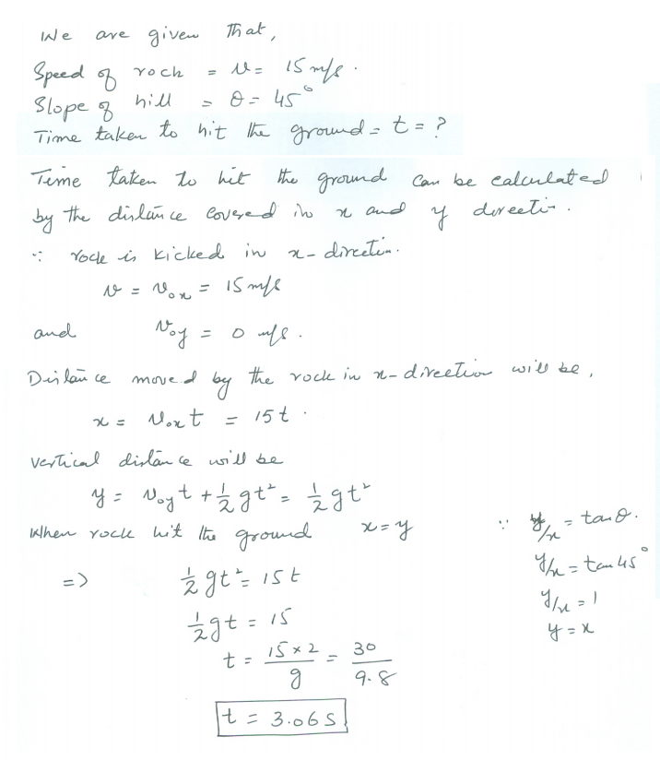

**Question 3 (a):** A space explorer is moving through space far from any planet or star. He notices a large rock, taken as a specimen from an alien planet, floating around the cabin of the ship. Should he push it gently, or should he kick it toward the storage compartment? Explain. (2 marks)

**Solution:**



**Question 3 (b):** A traction device employs $3$ pulleys to a patient in the hospital to stretch his recovering leg. The middle pulley is attached to a strap that ties with the patient foot. Suppose the patient puts a mass $m$ to supply tension on the ropes. (a) Draw the free-body diagram. (b) Resolve Newton’s 2nd law of motion into $x$ and $y$ components. (c) Find the value of that mass $m$ if the forces exerted on the strap by the middle pulley is $165 N$. Assume $g=9.81 m/s^{2}$. (8 marks)

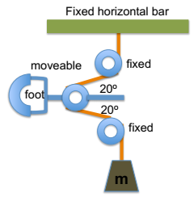

**Solution:**

